MY JOURNALS

My Journals Pages

My Journals Status 2

My Journals Page 3

View More Page 4

Header Information Page 4

Accounting Information Page 5

Summary Page 6

Attachments Page 6

My Journals Tasks

Create a journal 7

Edit a journal 7

Copy/Reverse/Delete a journal 8

Recall a journal 8

Copy and delete accounting line item 9

Show and Hide columns in Accounting Distribution grid 9

View as PDF 9

Download as Excel Spreadsheet 9

Add an attachment to a journal 10

Delete an attachment from a journal 10

**My Journals pages**



**My Journals status**

A status indicates the journal's state.

|  |  |
| --- | --- |
| **Status** | **Description** |
| Draft | * Draft = Journal saved as a draft and awaiting final submission. * Disapproved = Journal disapproved by the approver. * Automatic = Base automatic general voucher.   *You can edit and submit the journal in any of these statuses*. |
| Pending | |  | | --- | | * In Approval = Journal is pending approval in one of the Banner Finance Self-Service approval queues. * Deferred = Journal whose transaction edit processing is deferred to the Transaction Interface Process. | |
| Completed | |  | | --- | | Journal is approved and posted. | |

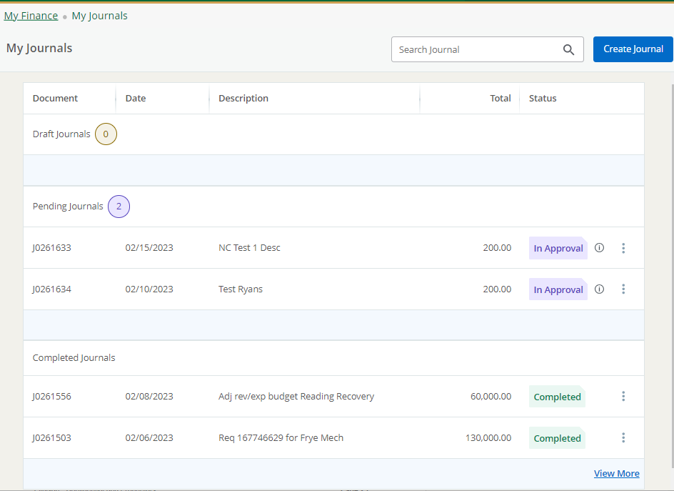

**My Journals page**

Access the My Journals home page to review the sections and perform associated tasks.

Use the My Journals page to create journals and view existing journals.

My Journals has three sections:

* Draft Journals
* Pending Journals
* Completed Journals

Journals appear in each section if available. The number of journals in each section is listed after the section's title. By default, only two journals are listed when a section contains more than two. To view more journals, click **View More** (bottom right corner).

Clicking the information icon  next to a journal's status provides a journal summary window which can also contain comments. For example, when a user disapproves a journal, they can add a comment explaining why they disapproved.

Click anywhere on the selected document row to view the journal’s detailed information. Click the **More Actions** icon  to perform additional actions like copy, reverse, delete, and recall.



**View More page**

Clicking **View More** on the dashboard allows you to view more journals of each section.

Use the filter icon to filter the document by statuses. Click the **More Actions** icon to perform additional actions like copy, reverse, delete, and recall.

Click anywhere in the selected document row to view the journal’s detailed information.

**Header information page**

This is the first page you see when you create a new journal.

Use the Header information page to create a journal's header information, and also edit and view the details.

For convenience, you can use the page to fill accounting defaults which defaults while creating accounting sequences in the same user session.

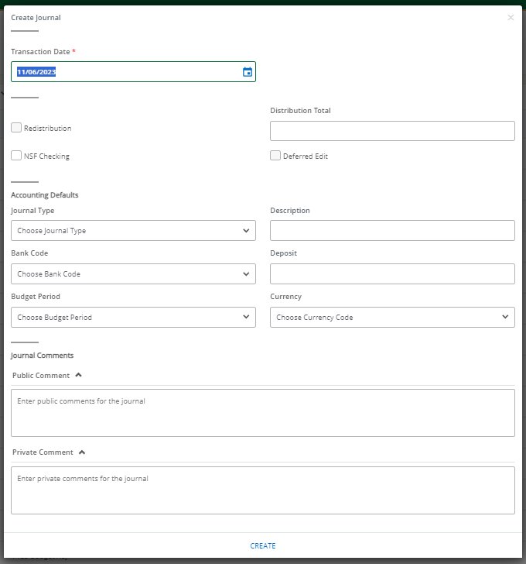

**Accounting information page**

Use the Accounting information page to create a journal's accounting information, and also edit and view the details.

For convenience, the accounting defaults that you enter on the header page will default for each accounting sequence. You can accept the default values, or select alternate values if needed.

After creating an accounting sequence, you can create another sequence by clicking **Add Accounting** without closing the overlay window. After saving an accounting sequence, My Journals validates the document and the resulting status displays as Postable, Error, or NSF error. This enables you to edit the information and make any necessary changes.

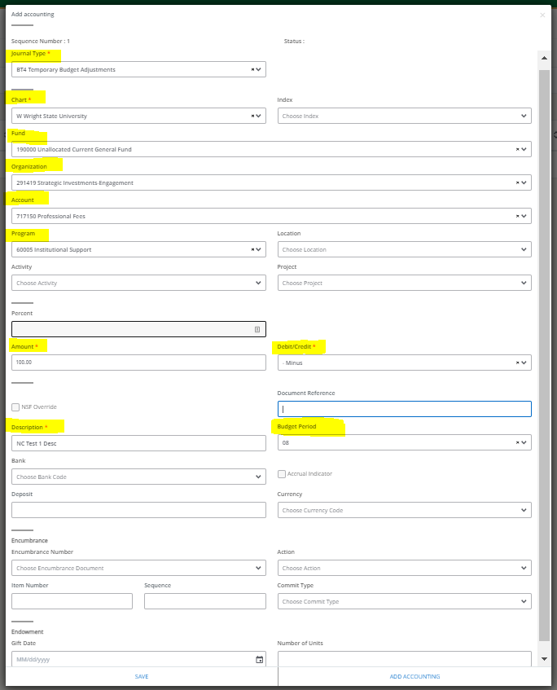

**Summary page**

The Summary page contains detailed information of the selected journals document.

In the **Summary** page, you can view and edit header and accounting information, view the journal details as a PDF, and download the details into an Excel spreadsheet.

Click the **More Actions** icon  to copy, reverse, delete, and recall the journal. Click the **Show/Hide** icon to show and hide any columns on the accounting distribution grid.

Click **Save as draft** to keep the document in the draft status. Click **Submit** (green box)to complete the document.

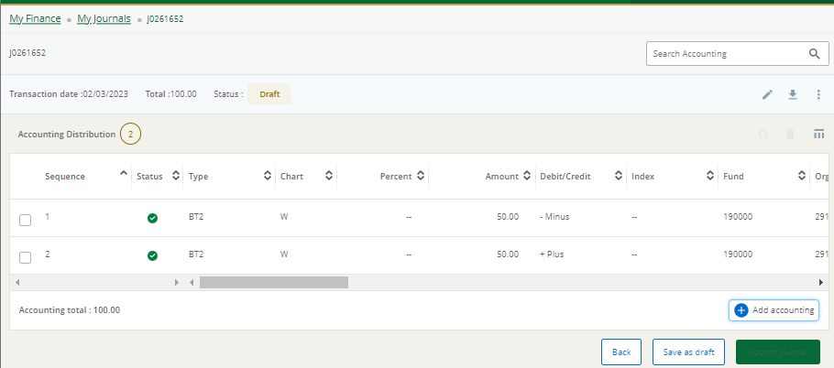

**Attachments page**

~~This page contains a list of the journal's attachments.~~

~~You can add, delete, and view attachments. When viewing any attachment, you can see the document stored in the B-F-DOCS application in Banner Document Management.~~

**For the time being, please continue to use the link from Banner 8 in WINGS Express to view or add attachments. This is a known issue in SSB9 that the Wright State team is actively working on. You can still create the journal in SSB9 and then go to SSB8 in WINGS Express to add the attachment(s).**

**My Journals pages**

**Create a Journal**

*To begin the journal process, use the My Journals dashboard page to create a journal.*

**Procedure**

1. On the **My Journals** dashboard page, click **Create Journal**.
2. On the **Create Journal** overlay window, specify Header information using the available fields.
3. Enter information in the **Accounting Defaults** section, if required to be defaulted in the **Accounting Distribution** page.
4. Enter information in the **Public Comment** and the **Private Comment** fields, if required.
5. Click **CREATE**.

Result: The Journal document is created with the header information and the **Summary** page displays with the **Add Accounting** overlay window.

1. On the **Add Accounting** overlay window, specify journal details using the available fields.
2. Click **SAVE**.

Result: The page refreshes with the accounting item you just added listed in the Accounting Distribution grid.

1. To add additional accounting items, click **Add accounting**.

Result: The **Add Accounting** overlay window displays. Repeat steps 6 and 7 to add more accounting items.

1. Click **Back** if you want to return to the **My Journals** dashboard.
   * Or, click **Save as draft** to mark the document as draft and return to the dashboard.
   * Or, click **Submit Journal** to send the journal for approval.

**Edit a Journal**

*You can edit any journal that is in Draft, Disapproved, and Automatic status.*

**Procedure**

1. On the **My Journals** dashboard page, click on any row under the Draft Journals section for the journal that you want to edit.
2. On the **Summary** page, click the **Edit Header** icon.

Result: The journal header overlay window displays.

1. Edit the header information, accounting defaults, and journal comments.
2. Click **UPDATE**.
3. On the **Summary** page, under the Accounting Distribution grid, click any accounting item to edit.

Result: **Accounting Distribution** overlay window displays.

1. Edit Accounting Distribution information.
2. Click **SAVE** or **ADD ACCOUNTING**.

Result:

* + If you click **SAVE**, the accounting item saves and closes.
  + If you click **ADD ACCOUNTING**, the existing record saves, and displays a new accounting distribution overlay window to add a new accounting item.

**Copy/Reverse/Delete a Journal**

*You can* ***copy*** *an existing journal and use it as a template for a new journal.  
You can* ***reverse*** *any journal.  
You can* ***delete*** *any journal that is in Draft, Disapproved, and Automatic status.*

**Procedure**

1. On the My Journals dashboard page, click the ellipsis, then click **Copy/Reverse/Delete Journal**.   
   You can also perform this action on the **View More** page and the **Summary** page.
2. On the copy/delete prompt, choose the appropriate option.  
   Note: Select the **Copy Comments** check box if you want to copy the journal document comments.

|  |  |  |  |
| --- | --- | --- | --- |
| **Option** | **Copy** | **Reverse** | **Delete** |
| OK | The system copies the journal and creates an identical new journal that you can edit. | The system reverses the journal. | The system deletes the journal. |
| Cancel | The system cancels the copy action. | The system cancels the reverse action. | The system cancels the delete action. |

**Recall a Journal**

*You can recall journals that are in the In Approval status.*

**Procedure**

1. On the My Journals dashboard page, click the ellipsis, then click Recall Journal.   
   You can also perform this action on the View More page and the Summary page.
2. On the reverse prompt, choose the appropriate option.

|  |  |
| --- | --- |
| **Option** | **Description** |
| YES | The system recalls the journal. The My Journals dashboard page loads with the recalled journal placed in the draft Journals section with a draft status. |
| NO | The system cancels the recall action. |

**Copy and delete accounting line item**

*You can copy and delete accounting line item for journals that are in Draft, Disapproved, and Automatic status.*

**Procedure**

1. Click the journal on the **My Journals** dashboard page.

The **Summary** page displays. You can also perform this action on the **View More** page.

1. Select the check box corresponding to the accounting item to copy or delete it.
2. Click the Copy or the Delete icon.

Result:

* On clicking Copy, the accounting line item get copied over to a new accounting item, and presented in the Edit mode.
* On clicking Delete, the delete sequence prompt displays.

1. On the delete prompt, choose the appropriate option.

|  |  |
| --- | --- |
| **Option** | **Description** |
| Yes | The system deletes the accounting item(s). |
| No | The system cancels the delete action. |

**Show and Hide columns in Accounting Distribution grid**

*You can hide or show accounting distribution information columns.*

**Procedure**

1. Click the journal on the **My Journals** dashboard page.  
   The **Summary** page displays. You can also perform this action on the **View More** page.
2. Click the Show/Hide icon.  
   Result: The list displays all the columns with a corresponding check box.  
   You can select the **All** check box to hide or show all the columns.

**View as PDF**

*You can download the journal as a PDF file to verify that the journal information is correct.*

**Procedure**

1. Open the journal that you want to view as a PDF.
2. Click the **Download** icon, then click **View PDF** to view the journal as a PDF file in a new tab.

**Download as Excel Spreadsheet**

*You can download a journal as an Excel spreadsheet to your local drive.*

**Procedure**

1. Open the journal that you want to download.
2. Click the **Download** icon, then click **Export to Excel** to view the journal as an Excel spreadsheet to the default download location on your drive.

**Add an attachment to a journal**

*~~After an attachment is created, you can add an attachment to the journal at any time before submitting the journal. You can add attachments to journals in Draft, Disapproved, or Automatic status.~~*

**~~Procedure~~**

1. ~~Open the journal in Draft or Disapproved or Automatic status to which you want to add an attachment.~~
2. ~~Click the~~ **~~Attachments~~** ~~icon.~~
3. ~~Click~~ **~~Attach File~~**~~.~~
4. ~~Using the~~ **~~Attach Documents~~** ~~prompt, choose a file to attach.~~
5. ~~Select the~~ **~~Document Type~~**~~.~~
6. ~~Click~~ **~~Upload~~**~~.~~

~~Result: The file is added to the Attachments page list.~~

**For the time being, this is not working in SSB9, continue to use SSB8.**

**Delete an attachment from a journal**

*~~If you want to delete an attachment from a journal in Draft, Disapproved, and Automatic status, you can use the Attachments page to delete one or more attachments.~~*

**~~Procedure~~**

1. ~~Open the journal containing the attachment you want to delete.~~
2. ~~Click~~ **~~Attachments~~**~~.~~
3. ~~On the~~ **~~Attachments~~** ~~page, click the attachment that you want to delete in the Attachments list, and then click~~ **~~Delete~~**~~.~~
4. ~~Confirm that you want to delete the attachment.~~

**For the time being, this is not working in SSB9, continue to use SSB8.**