* How to get to your approval queue in SSB9:
  + Go to **WINGS** (link is at the top of <https://www.wright.edu/>)
  + Choose **Finance** from *Your Launchpad* (list on the right)
  + Choose **Approve Documents** on the *My Finance* screen
    - Enter User ID (W#)
    - Choose *User ID is next approver*
    - Click **Submit**
* Choose a document to review. Click on the document number (first column) and a new tab will open with a PDF of the document for your review.
* Return to the *Approve Documents* tab to **Approve** or disapprove the document by clicking on the appropriate button on that documents row.

From the Wright.edu main page – click on **WINGS**

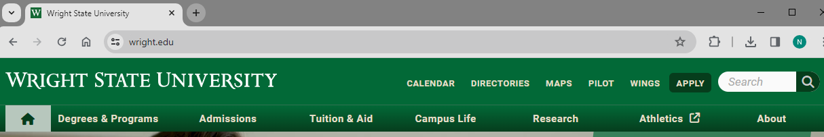

Choose **Finance** from *Your Launchpad*

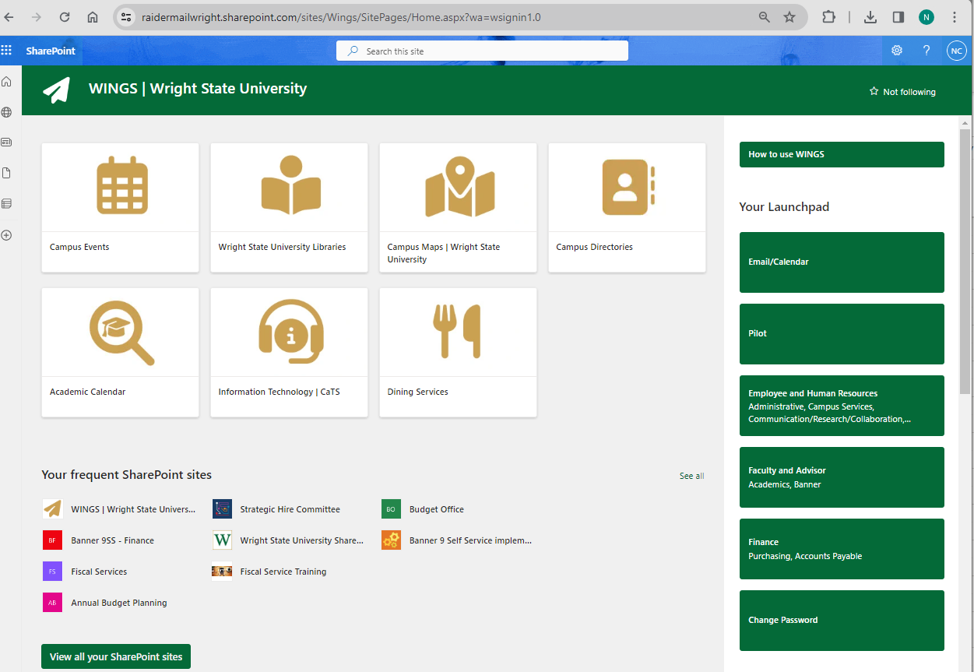

Choose **Approve Documents** from the menu options under *My Finance*

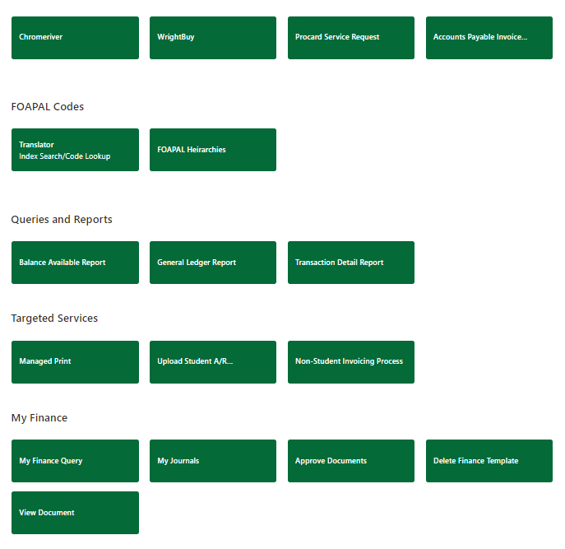

Enter your W# in the *User ID* field and click **Submit** (you only need to enter your ID one time, the system will save it the next time you log in)   
*this is the same process as in SSB8

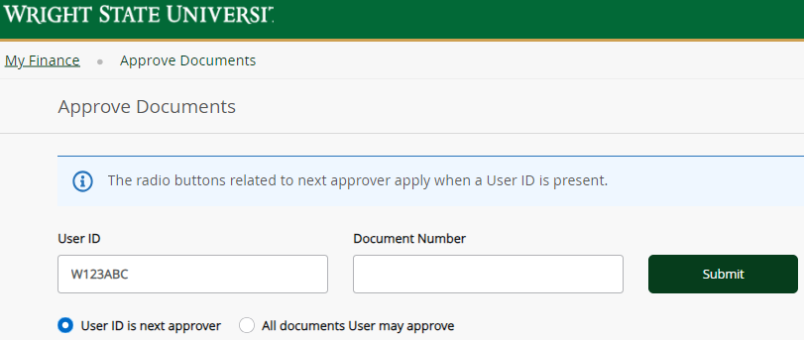

A list of the documents for which you are the next approver will be displayed. Click on the document number to view the document – it will open as a PDF in a new tab. Return to the *Approve Documents* tab to **Disapprove** or **Approve**

