Create a Journal – BT2, BT4, & J16

To begin the journal process, use the My Journals dashboard page to create a journal.

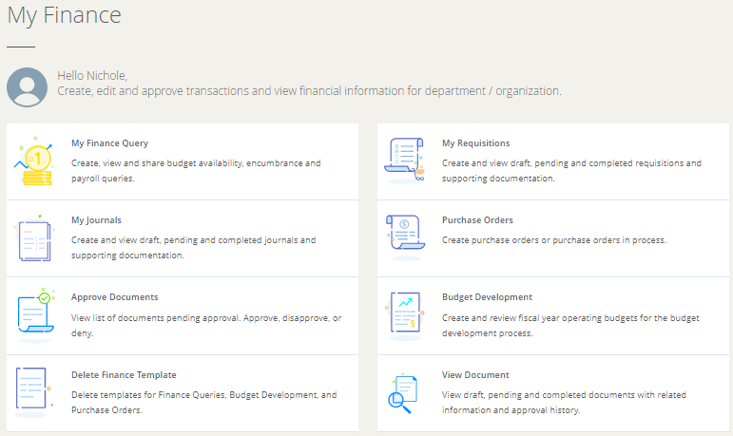

Procedure

1. On the My Journals dashboard page, click Create Journal.
2. On the Create Journal overlay window, specify Header information using the available fields.
   * Enter information in the Accounting Defaults section, if required to be defaulted in the Accounting Distribution page.
   * Enter information in the Public Comment and the Private Comment fields, if required.
   * Click CREATE.

Result: The Journal document is created with the header information and the Summary page displays with the Add Accounting overlay window.

1. On the Add Accounting overlay window, specify journal details using the available fields.
   * Click SAVE.

Result: The page refreshes with the accounting item you just added listed in the Accounting Distribution grid.

* + To add additional accounting items, click Add accounting.

Result: The Add Accounting overlay window displays. Repeat steps 6 and 7 to add more accounting items.

1. Click Back if you want to return to the My Journals dashboard.

* Or, click Save as draft to mark the document as draft and return to the dashboard.
* Or, click Submit Journal to send the journal for approval.

1. On the My Journals dashboard page, click Create Journal

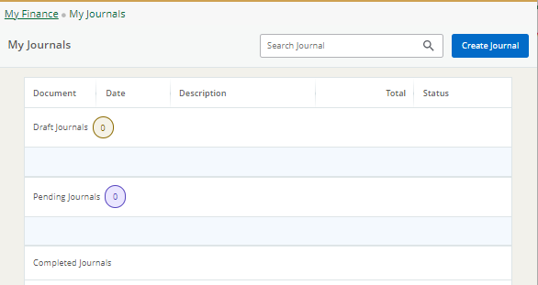

1. On the Create Journal overlay window, specify Header information using the available fields.

* Transaction Date – you can enter as mmddyy and it will automatically convert it to the mm/dd/yyyy format
* Journal Type – there are significantly more options that you will need, just start typing the type you are creating to select it from the list instead of scrolling all the way through. **Common Types: BT2, BT4, J16**
* Description – not required but will serve as the default description for all lines of the journal. You can override/edit this in subsequent screens
* Budget Period – choose/type correct budget period, should match the period of the Transaction Date you entered
* Public Comment – aka Printable Comments will appear in header of the journal (this is the same as the Document Text in Banner 8)

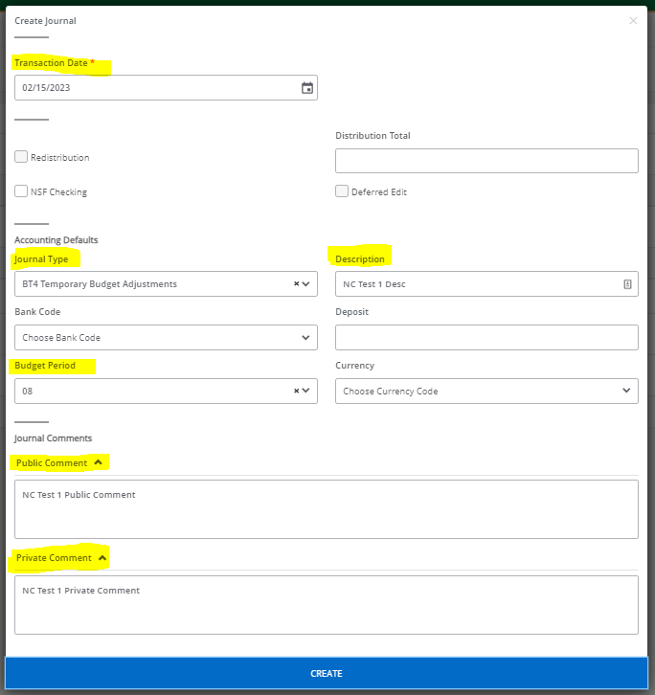

1. Enter information in the Accounting Defaults section, if required to be defaulted in the Accounting Distribution page.

* Journal Type – defaults based on selection in previous screen
* Chart – always W Wright State University, should default
* Fund, Organization, Account, Program
* Amount – must be a POSITIVE number
* Debit/Credit – use *-Minus* and *+Plus* for BT’s & J16’s
  + (*-Minus* = where $ is coming from, *+Plus* = where $ is going to)
* Description – will default to what you entered in the previous screen but you can override it if needed here
* Budget Period – will default based on selection in previous screen, you should not change

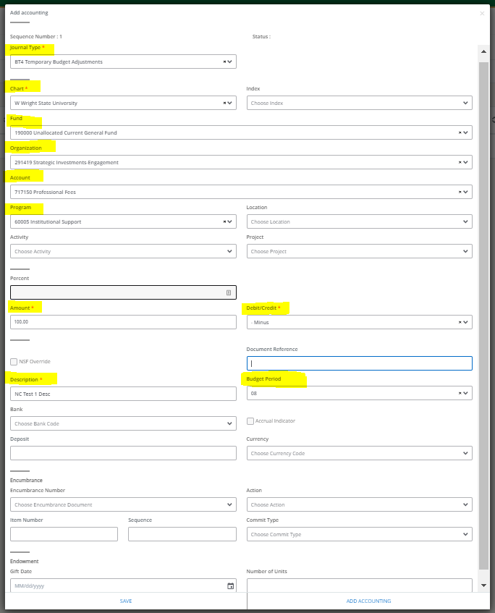

Each Sequence Number is a line in the Journal entry, you will complete 1 sequence/line at a time. To add additional sequences/lines, click ADD ACCOUNTING after completing a sequence and you will see a new identical Add Accounting screen that now says Sequence Number: 2 and you will complete the same fields until all sequences/lines are completed, then you will click SAVE.

Click the Green Box and you will get a pop-up box that says “Do you want to submit journal J#######? And here you can click YES to submit