Prerequisite Check in Cognos
Follow these steps to run a prerequisite report.
Login to Cognos via WINGS | Employee Tab.

Click on the folders:
Production
Course Information Reports
Course Detail Lists
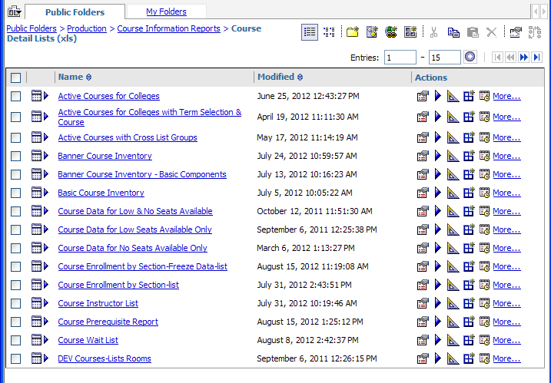

In the example, below we are checking all students registered for ENG 2100 in the Fall 2012 semester to see if they have earned ENG 101 or ENG 111 on their transcript with a grade of C or better. (ENG 111 was the equivalent to ENG 101 in WSU’s early days). Courses listed in the left hand column are single courses, any of which will satisfy the prerequisite. Courses listed in the right hand column are all required to satisfy a prerequisite. Never insert spaces between the subject and course number.
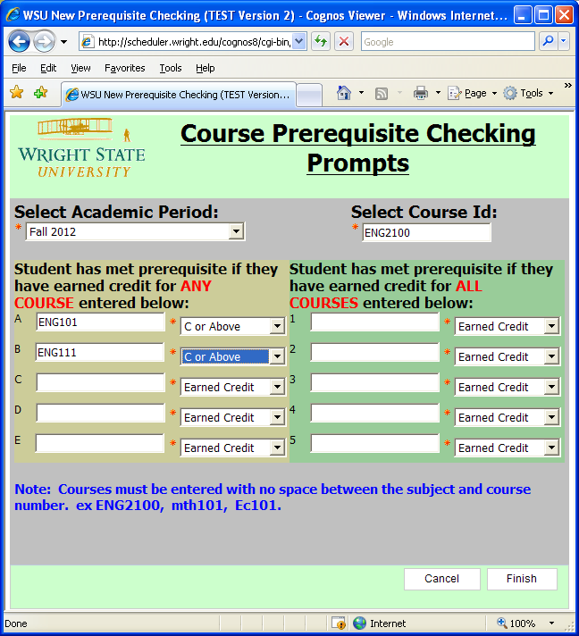

Students listed on the report do not meet prerequisites entered in the prompts by the user. The user controls which prompts are used. Courses “In –Progress” do not satisfy the prerequisite but do display on the report.
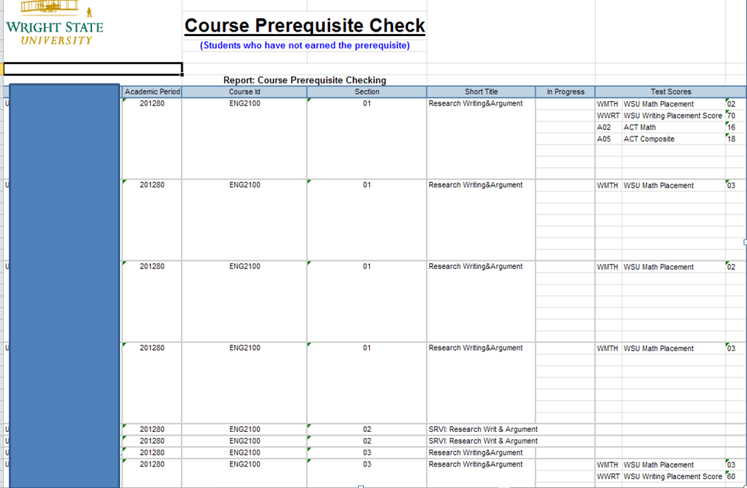
It is possible that students identified on the report have transferred a course from another institution that may satisfy the prerequisite but the course is not articulated to ENG 101. Only an evaluation of the course title/syllabus of the original course can determine whether the student has met the prerequisite. Test Scores are displayed on the early release of the report but will be a prompt, like a course that can satisfy the prereq, in a future release.

